Project Design Phase-II

Data Flow Diagram & User Stories

Date | 15 October 2022
Team ID | PNT2022TMID47645
Project Name | Project – Smart Farmer-IoT Enabled smart Farming Application
Maximum Marks | 4 Marks

Smart Farming Application Flow Diagram (simplified)

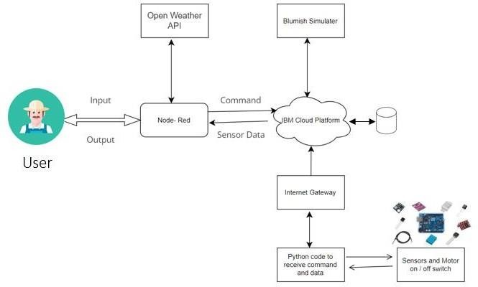

Data Flow Diagrams:

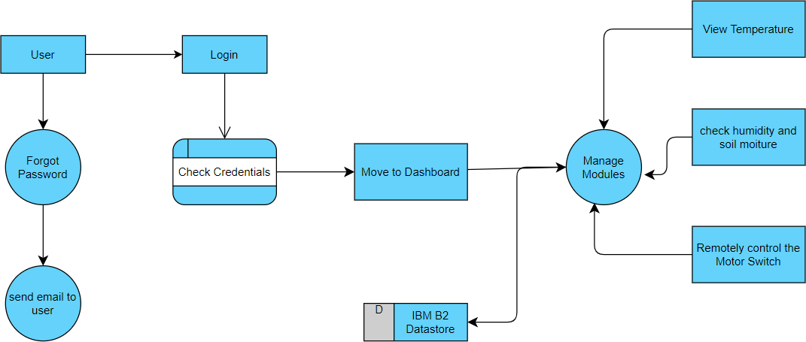

User Stories

User Type | Functional Requirement (Epic) | User Story Number | User Story / Task | Acceptance criteria | Priority | Release
Customer (Mobile user) | Registration | USN-1 | As a user, I can register for the application by entering my email, password, and confirming my password. | I can access my account / dashboard | High | Sprint-1
 |  | USN-2 | As a user, I will receive confirmation email  once I have registered for the application | I can receive confirmation  email & click confirm | High | Sprint-1
 |  | USN-3 | As a user, I can register for the application through Gmail |  | Medium | Sprint-1
 | Login | USN-4 | As a user, I can log into the application by entering email & password |  | High | Sprint-1
Customer (Web user) | Dashboard | USN-5 | As a User can view the dashboard, and this  dashboard include the check roles of access and then move to the manage modules. | I can view the dashboard  in this smart farming application system. | High | Sprint 2
 |  | USN-6 | User can remotely access the motor switch | In the smart farming app | High | Sprint 3
Administrator |  |  | As a user once view the manage modules this describes the Manage system Admins and  Manage Roles of User and etc. |  |  | Sprint 2

